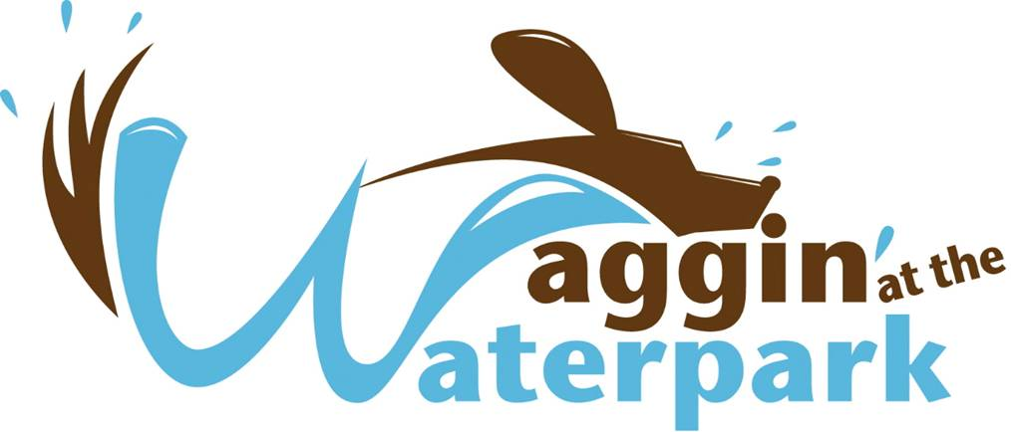 

**Discovery Island Water Park – Saturday, September 10, 2022**

**Otter Creek Water Park – Saturday, September 17, 2022**

**9:00 a.m. –2:00 p.m.**

**EVENT WILL BE HELD RAIN OR SHINE!**

**2022 Vendor Application**

Name of Business: __________________________________________________________________________

Contact: _____________________________________ Title: ________________________________________

Mailing Address: ___________________________________________________________________________

City, State: _____________________________________________________ Zip: ______________________

Primary Phone: _____________________________ Email: _________________________________________

Business Website: __________________________________________________________________________

Description of retail items: ___________________________________________________________________

Additional Booth Needs (Electricity, water, extra space, etc.): _______________________________________

*There is no charge for non-profit organizations; however you must provide the following information:*

* I am a 501c3 / Nonprofit Agency OR a Nonprofit Rescue Group.
* My Tax ID # is ___________________________ and a copy of our IRS Designation is attached.

**\*\* ALL Vendors must provide a copy of current Liability Insurance Certificate with Greenville County stated as an “additional insured”. \*\***

**CHECK WHICH EVENT YOU WILL ATTEND:**

* Discovery Island (Sat. Sept. 10 – 9:00 a.m. – 2:00 p.m.) - $40.00 In County; $50.00 Out of County
* Otter Creek (Sat. Sept. 17 – 9:00 a.m. – 2:00 p.m.) - $40.00 In County, $50.00 Out of County
* Both Events - $60.00 In County, $75.00 Out of County

$_____TOTAL

Please use separate attached form if using credit/debit card. Checks must have phone #, DL#, State Issued.

**Vendor Info**

**Location: Both vendor fairs will be located inside the waterparks near all of the activity!**

**Set up time:** Must be set up by **8:30 a.m.** to greet participants as they enter.

**Deadline for entry:** September 8, 2022 for Waggin @ Discovery Island and if you are vending at **BOTH** events; September 13, 2022 for Otter Creek.

**Booth Size:** Approximately 10x10, assigned day of on first come, first serve basis.

**Contact:** Clarissa Suttle, Program Manager

Greenville County Rec

4806 Old Spartanburg Rd

Taylors, SC 29687

(864) 467-3324 csuttle@greenvillecounty.org [www.greenvillerec.com](http://www.greenvillerec.com)

Completed application must accompany signed Vendor Rules and Agreement and payment for Vendor to be officially registered.

**THANK YOU FOR YOUR TIME AND INTEREST IN VENDING AT WAGGIN’ AT THE WATERPARK.**

***Waggin’ at the Waterpark***

**Discovery Island Waterpark – Saturday, September 10, 2022**

**Otter Creek Waterpark – Saturday, September 17, 2022**

**9:00 a.m. – 2:00 p.m.**

**EVENT WILL BE HELD RAIN OR SHINE!**

**PLEASE READ PRIOR TO DAY OF EVENT!**

1. All vendors must include payment with application, and return this signed agreement to be considered officially registered. Vendor will receive confirmation when application is accepted.
2. **Vendor must provide a copy of current Liability Insurance Certificate with Greenville County listed as an “Additional Insured”** with application.
3. Vendor booth spaces will be in the Vendor Fair, located inside the waterpark for maximum exposure. Exact location will be determined on a first come, first served basis. You will be assigned a booth space when you arrive.
4. Vendor space size will be approximately 10 x 10. Vendor must supply their own **canopy *(it gets hot)*,** table and chairs. If additional space or particular requirements are needed (water, electricity) please specify on form at “Additional Booth Needs”.
5. Trash receptacles will be available at the park, however we ask vendors to remove boxes, and large items from the park as they leave. All trash from your vendor area must be properly disposed of before leaving the event. Organizers reserve the right not to invite a vendor back if their area is not left in good order.
6. All supplies need to be on site by 8:30 a.m. with vehicles removed to parking lots adjacent to the park. No vehicles will be able to park close to the vendor sites until the event has ended. Please pay special attention to time in this regard, as we want to protect our canine friends.
7. Vendor may not leave an animal unattended at any time during the event. **Vendors will be allowed to have one dog entered in the time allotted for their particular size and weight; you must provide proof of current vaccines – Rabies, Parvo, Bordatella (kennel cough). Rabies tag is not sufficient proof.**
8. If a vendor cancels before September 6, 2022, if registering for Discovery Island or both sites, a refund will be issued less a $15 administrative fee. If a vendor cancels before September 13, 2022, if registering Otter Creek, a refund will be issued less a $15 administrative fee. No refunds after September 6th for Discovery Island or both sites, no refunds after September 13th for Otter Creek.

*I ____________________________________ (vendor name, business owner), agree to the above stated terms in order to be a vendor at Waggin’ at the Waterpark.*

*________________________________________________ ___________________________*

*Signature Date*

***Check the following:***

***___ Certificate of Insurance with Greenville County listed as “Additional Insured”.***

***____ 501c3 Tax Id # (If non-profit).***

***____ If bringing a dog, proof of current vaccines from administering veterinarian (Rabies, Parvo, and Bordetella) are required. Rabies tag will not be accepted as proof.***

**Vendor Dog Registration for Waggin’ at the Waterpark**

**PLEASE ATTACH PROOF OF CURRENT VACCINATIONS WITH THIS FORM.**

**DOGS WILL NOT BE ADMITTED WITHOUT THIS DOCUMENTATION!**

**(Documentation must show current date from administering veterinarian.)**

**____Rabies ____ Parvo/Distemper *(will read as DHPP, DA2PP, DHPPV, Da2PPv on records)* ____ Bordetella (kennel cough)**

***(Bordetella for Kennel Cough is normally given by your veterinarian if your dog boards at a kennel, goes to doggie day care, or goes to public dog parks, however, our consulting veterinarians (Greenville County Animal Care), recommend this vaccine to the dogs participating in Waggin’ because of the high content of ptyalism (hypersalivation) and close contact among the dogs in & out of the water.)***

**\*\*NOTE: If your female dog has not been spayed, she cannot participate in Waggin’ if she is in Estrus (in heat).**

**Owner Last Name: ___________________________________ Owner First Name: _________________________________**

**Dog Name: _____________________ Breed: _______________________Weight_______ Age: _____ Male: ____ Female: _____**

**Address: _______________________________________________ City: ______________________ State: ______ Zip: _________**

**Primary Phone: ________________________________________ Email: _____________________________________________**

***To keep our happy tails waggin’, please obey to the Waggin’ Rules!***

**Waggin’ Rule #1**

No human swimming. You may wade with your dog, but remember doggies do pee/poop when they get excited! Do not swim under the water.

**Waggin’ Rule #2**

Your dog may be leash-free once he/she is inside the waterpark. Please remain within 10 feet of your dog at all times. Please help our staff by keeping your dog away from the entrance/exit gates. Some dogs want to know what’s beyond the waterpark fence!

**Waggin’ Rule #3**

You must clean up after your dog. We have poop bags and trash receptacles available throughout the waterpark. If your dog accidentally poops in the water, please let a lifeguard or staff member know immediately.

**Waggin’ Rule #4**

If your dog shows aggressive behavior toward another dog or human, he/she will be placed in Doggie Time Out located outside of the waterpark. He/she will not be able to return to the fun until his/her behavior has subsided. If the problem continues, you may be asked to call it a day and take your dog home.

**Waggin’ Rule #5**

Female dogs that have not been spayed cannot participate at Waggin’ during Estrus (in heat).

**Waggin’ Rule #6**

You must have proof of all vaccines that are required (rabies, parvo, & Bordetella), from the administering veterinarian; a rabies tag is NOT ACCEPTABLE PROOF.

**Last but not least, you and your four-legged pal are required to have a great time!**

***Spread the word about Waggin’ to all of your doggie-loving friends!***

***Waggin’ will be held rain or shine!!***

***No waterpark season or free passes will be accepted for entrance to this event.***



**Release of Liability and Indemnification Agreement**

**Waggin’ at the Waterpark**

**Discovery Island, Saturday, September 10, 2022**

**Otter Creek, Saturday, September 17, 2022**

I acknowledge that I voluntarily have applied to participate and use with my dog(s) Discovery Island Waterpark and/or Otter Creek Waterpark (“the waterpark”) for the swimming event on Saturday, September 10, 2022 and/or Saturday, September 17, 2022.

I understand that the act of unleashing my dog(s) and being physically present inside the waterpark area necessarily involves risks of injury to me, to other people, to my dog(s), and to other dog(s). I understand these risks are entirely my responsibility. I expressly assume these risks. I am aware of the risks and hazards inherent upon entering the waterpark area and I choose to voluntarily enter the premises, knowing the conditions might become more hazardous and/or dangerous for myself and/or dog(s) and I voluntarily assume all such risks, loss, damages, or injury that may be sustained by entering the waterpark.

By signing this release of liability and using the waterpark, I hereby fully and forever release and discharge Greenville County Parks, Recreation & Tourism, County of Greenville, their volunteers, employees and agents from any claims, demands, damages, rights of action or causes of action present or future, whether the same be known or unknown, anticipated or unanticipated, resulting from or arising out of my use or intended use of the waterpark. I fully and forever release and discharge Greenville County Parks, Recreation & Tourism, County of Greenville, and their employees and agents from any and all negligent acts and omissions in the same.

By signing this agreement I also agree to indemnify Greenville County Parks, Recreation & Tourism, County of Greenville, and their volunteers, employees and agents from any claims, demands, damages, rights of action or causes of action present or future, whether the same be known or unknown, anticipated or unanticipated, brought against any or all of such entities based on my use or intended use of the waterpark.

I have carefully read this release of liability and understand and fully agree with its contents.

**This is a release of liability. Do not sign if you do not understand or do not agree with its terms. Any owner/handler using the waterpark must sign the waiver.**

Owner / Handler’s Name (printed): ______________________________________

Owner / Handler’s Signature: ______________________________________ Date:_____________

  



Date: ____________

By: ______________

**\*PLEASE PRINT LEGIBLY \***

**Cardholder’s Name: Credit Card Billing Zip Code: (required)**

**___________________________________________ _____________________________________**

***(As It Appears On Card) (From Card Billing Address)***

***Card Number: ________________________________ Expires: __________ CVV Code: _________***

***Destroyed After System Entry***

**Card Information**

**I authorize Greenville County Parks, Recreation, & Tourism to automatically charge my credit/debit card on file for any fees incurred at registration. I agree that I will pay for these charges in accordance with the issuing bank cardholder’s agreement.**

**Cardholder’s Signature: Date:**

**______________________________________________ ______________________________________**

**Payment Information**

**Last Name: __________________________________________ First Name: ______________________________**

**Address: ______________________________________City:_____________________ State: ____Zip:________**

**Phone Number: _______________________________ Email Address: __________________________________**

**Customer Information**

**For security and protection of your financial information**

**RETURN BY US MAIL OR HAND DELIVER ONLY**

**Greenville County Parks, Recreation, & Tourism**

**4806 Old Spartanburg Road**

**Taylors, SC 29687**

**(864) 288-6470**

**Credit/Debit Card Payment Authorization Form**